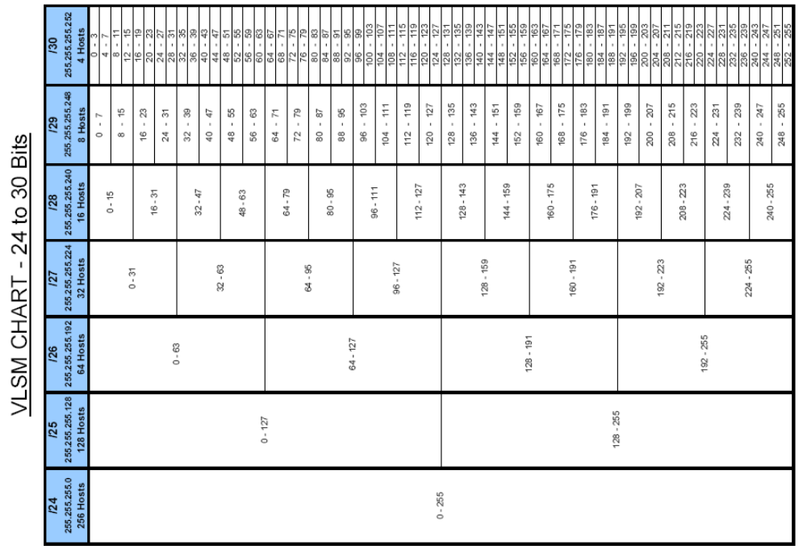
VLSM Exercise # 1

Student Name: ___________________________________________________ Student Number: ______________________

Design an appropriate VLSM addressing scheme for the topology. Maximize the number of host addresses at each level of subnetting.

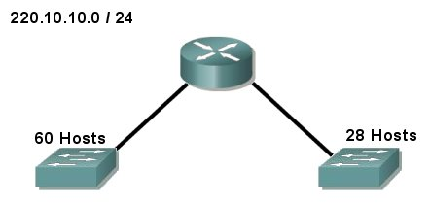

VLSM Exercise # 2

Student Name: ___________________________________________________ Student Number: ______________________

Design an appropriate VLSM addressing scheme for the topology. Maximize the number of host addresses at each level of subnetting.

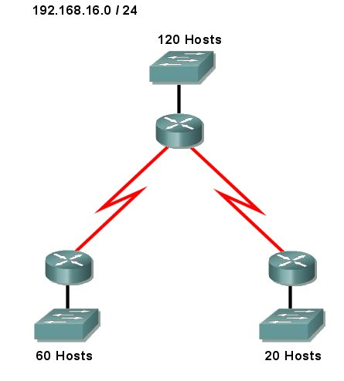

VLSM Exercise # 3

Student Name: ___________________________________________________ Student Number: ______________________

Design an appropriate VLSM addressing scheme for the topology. Maximize the number of host addresses at each level of subnetting.

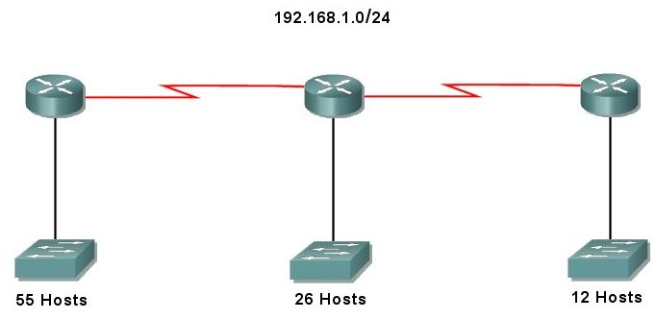

VLSM Exercise # 4

Student Name: ___________________________________________________ Student Number: ______________________

Design an appropriate VLSM addressing scheme for the topology. Maximize the number of host addresses at each level of subnetting.

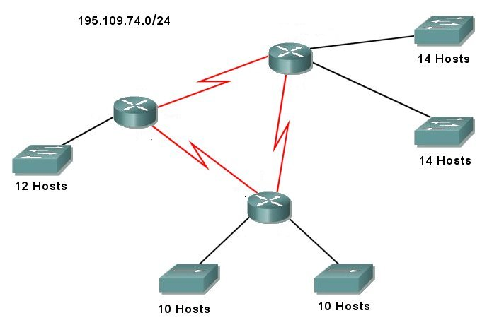

VLSM Exercise # 5

Student Name: ___________________________________________________ Student Number: ______________________

Design an appropriate VLSM addressing scheme for the topology. Maximize the number of host addresses at each level of subnetting.

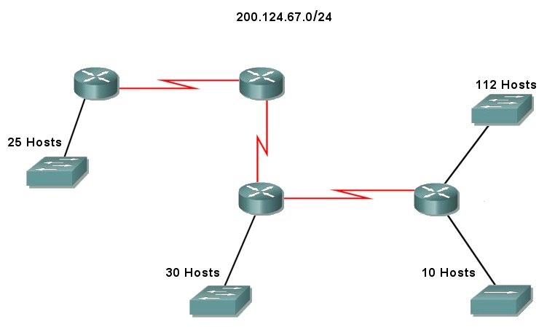

VLSM Exercise # 6

Student Name: ___________________________________________________ Student Number: ______________________

Design an appropriate VLSM addressing scheme for the topology. Maximize the number of host addresses at each level of subnetting.

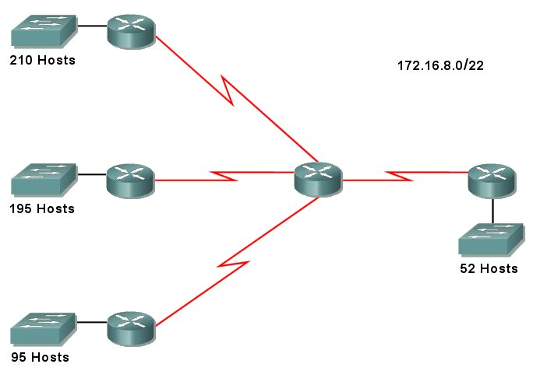

VLSM Exercise # 7

Student Name: ___________________________________________________ Student Number: ______________________

Design an appropriate VLSM addressing scheme for the topology. Maximize the number of host addresses at each level of subnetting.

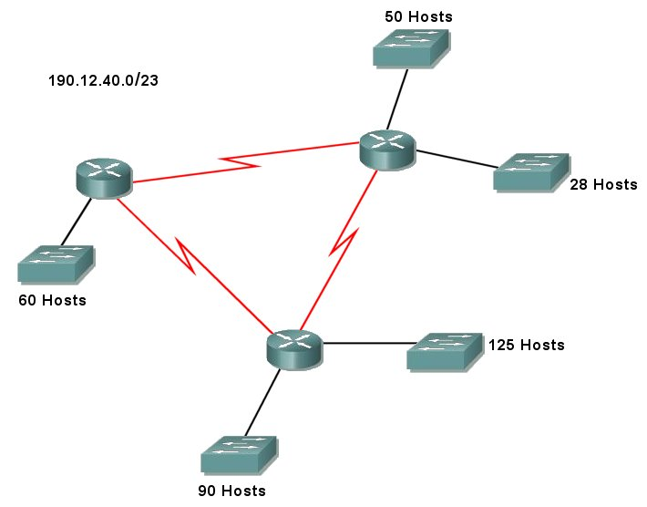

VLSM Exercise # 8

Student Name: ___________________________________________________ Student Number: ______________________

Design an appropriate VLSM addressing scheme for the topology. Maximize the number of host addresses at each level of subnetting.

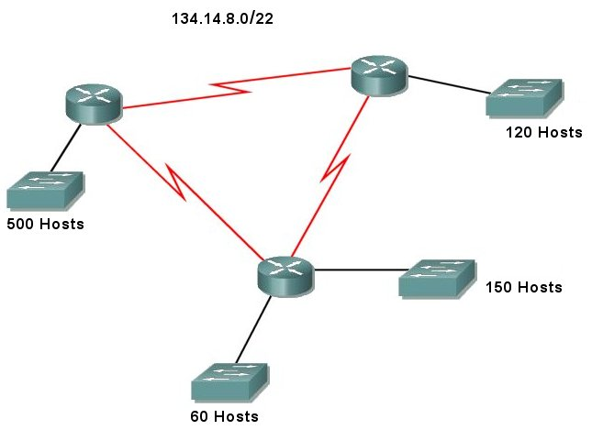

Solution - VLSM Exercise # 9

Student Name: ___________________________________________________ Student Number: ______________________

Design an appropriate VLSM addressing scheme for the topology. Maximize the number of host addresses at each level of subnetting.

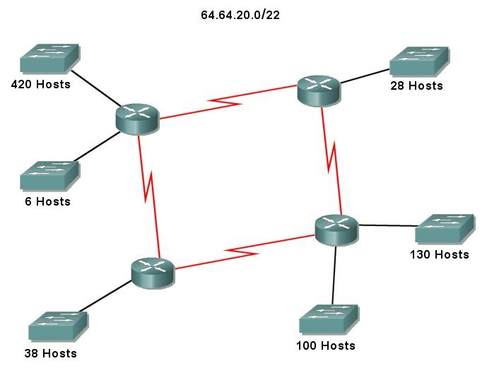

VLSM Exercise # 10

Student Name: ___________________________________________________ Student Number: ______________________

Design an appropriate VLSM addressing scheme for the topology. Maximize the number of host addresses at each level of subnetting.

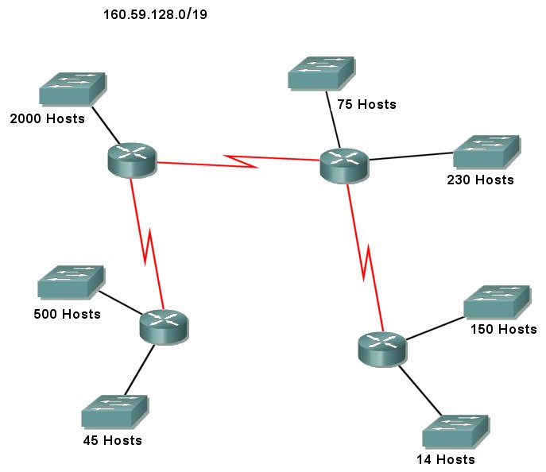

VLSM Exercise # 11

Student Name: ___________________________________________________ Student Number: ______________________

Design an appropriate VLSM addressing scheme for the topology. Maximize the number of host addresses at each level of subnetting.

